Discussion:

Another genome-wide significant variant, chr2:218260234, for the sex joint test is located in the intron of *DIRC3* and associated with body height, breast and thyroid carcinoma, lean body mass, bone density. The *DIRC3* gene is associated with non-papillary renal cell carcinoma and breast cancer. From GTEx analysis, 2:218260234 has an eQTL relationship with skin (sun exposed). While worse COVID-19 outcomes were substantially higher in cancer patients in population-based studies, genetic studies have yet to investigate this association (Robilotti et al., 2020; Liang et al. 2020; Al-Quteimat & Amer, 2020). However, the immunosuppressed status of cancer patients receiving treatment place individuals at higher risk of COVID-19 severity. While future research is required to elicit the biological basis of different immune system responses, the gene-environment interaction of these variants with sex and COVID-19 severity suggests mechanisms that may put individuals at higher risk.

A. 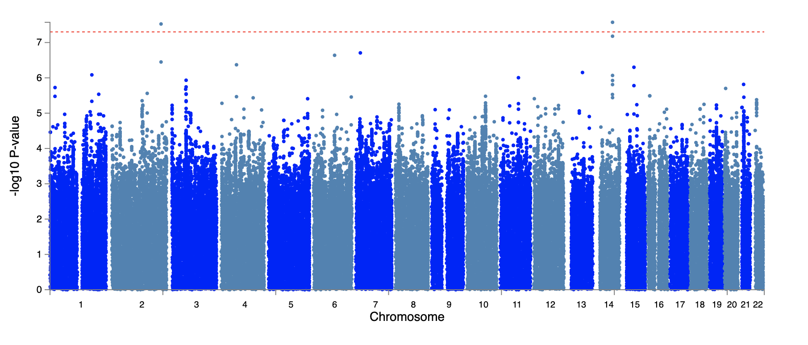

B. 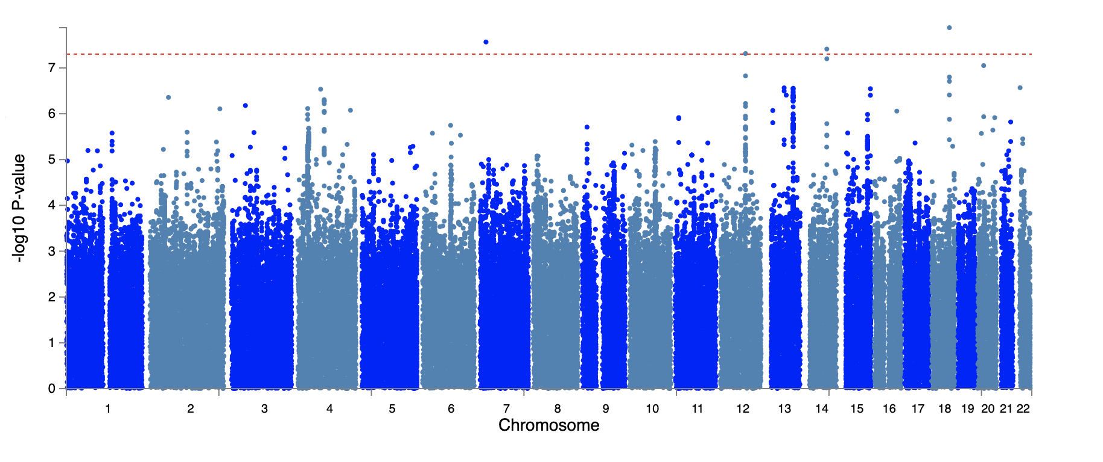

C. 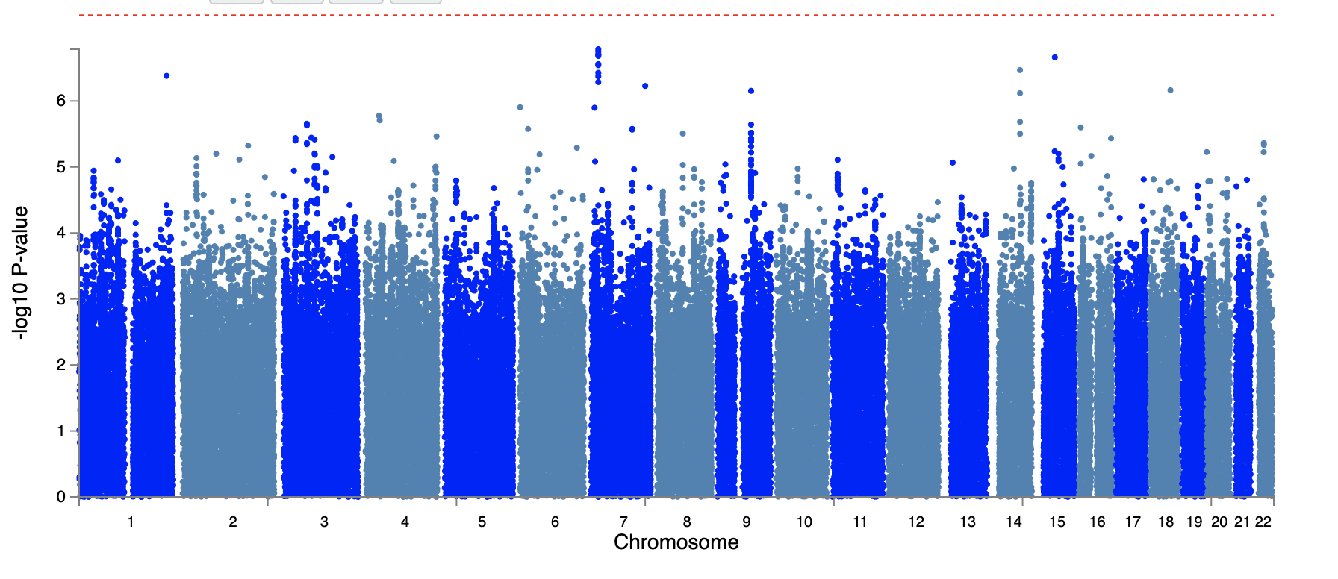

**Fig. 1: Miami plot of the genome-wide sex joint test effects. A.** Sexjoint tests showed a signal at Chr 2 and 14. Variants 2:218260234 and rs2268616 were identified as genome-wide significant. **B.** In the cardiometabolic joint test, strong loci were identified. rs2268616, rs148793499, and rs11115199 were genome-wide significant. **C.** In the MDI joint test, no variants passed the genome-wide significant threshold (5E-08). However, rs2268616 was suggestively significant (p<1E-06).

1. 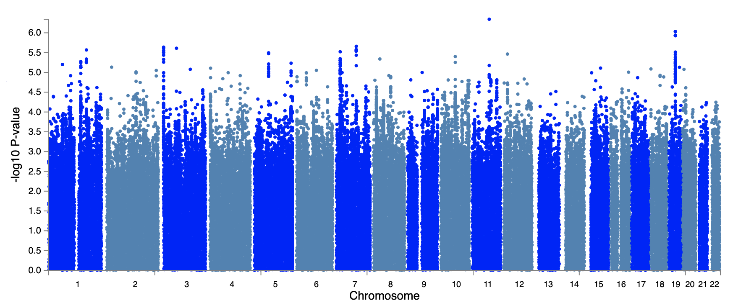
2. 
3. 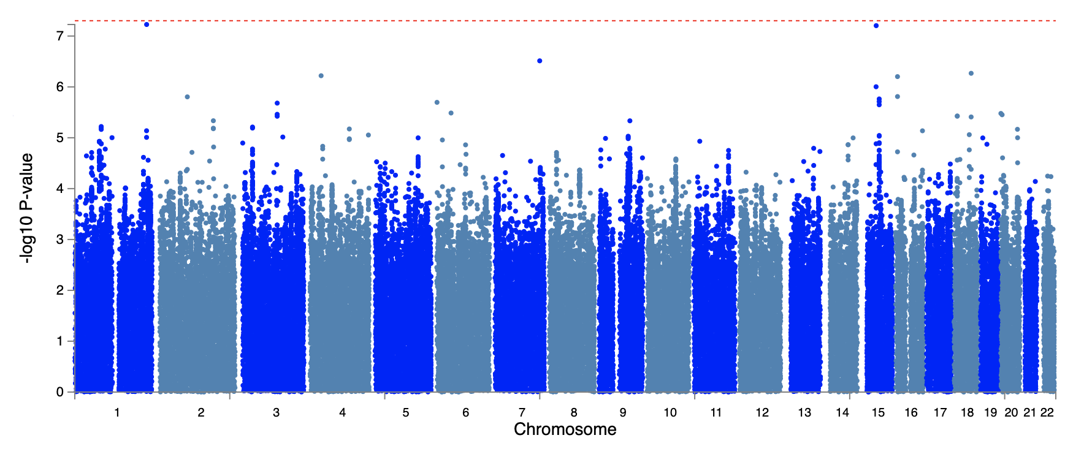

**Fig. 2: Manhattan plot of the genome-wide sex interaction test effects. A.** Sexinteraction tests did not show any strong signals or genome-wide significant variants. **B.** Cardiometabolic interaction tests showed several suggestive loci, but only identified one genome-wide significant variant (rs11115199, p=1.37e-08). **C.** MDI interaction tests did not find any variants that passed the genome-wide significant threshold (p<5E-08).

**A.** 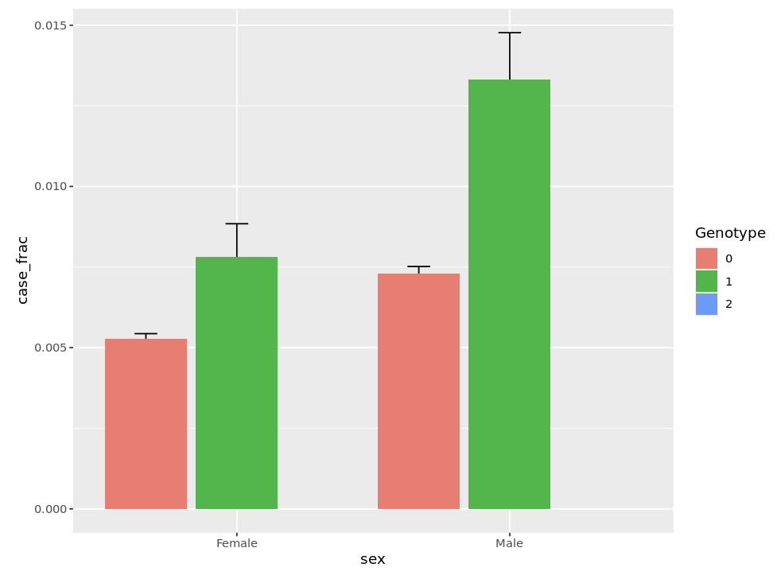

**B.** 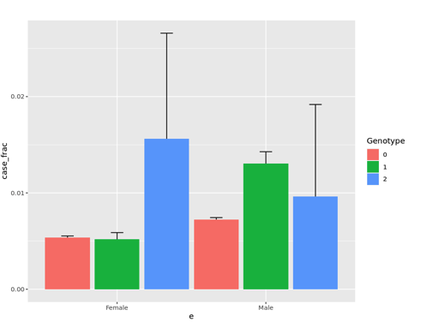

**Figure 3: Stratified sex analyses of genome-wide significant GxE variants rs2268616. A.** For rs2268616, the male heterozygous genotype have a higher prevalence of cases when stratified and experience a strong genetic effect (OR=1.79, CI=[1.43-2.24]), while females have a slight genetic effect (OR=1.45, CI=[1.11-1.9]). Since there are no cases for genotype 2, we cannot fully observe a clear association and additive effect, but we can observe heterozygous individuals, especially male, have more cases of worse outcomes of COVID. **B.** For variant chr2:218260234, male heterozygous individuals have a strong genetic effect and high prevalence of cases when stratified (OR=1.8, CI=[1.47-2.19]), which was not seen in females (OR=1.03, CI=[0.779-1.35]). Female homozygous genotypes have a slightly higher prevalence of cases when stratified. The small sample size causes limitations in our stratified genotype analysis of rs11115199 and rs148793499 since there are no homozygous recessive genotype cases for T2D compared to obesity.

**NOTE: p_Value_marginal**

rs2268616 p=1.07885e-08

2:218260234_AC_A p=7.83969e-06

rs11115199 p= 0.408961

rs148793499 p=5.76211e-05

Rs182113773 p= 1.38578e-08; pint = 0.0529514 ,p_ joint = 2.71316e-08